ASSIGNMENT – 2

Download Data set: - Pharma-Sales-Dataset

Challenge: - Upload the dataset to Cognos Analytics, prepare the data, explore and Create Interactive Dashboard.

Link to assignment dashboard : <https://us3.ca.analytics.ibm.com/bi/?perspective=dashboard&pathRef=.my_folders%2FAssignment%2B2&action=view&mode=dashboard&subView=model00000183c5964e3e_00000000>

Task 1: Sales by Customer.

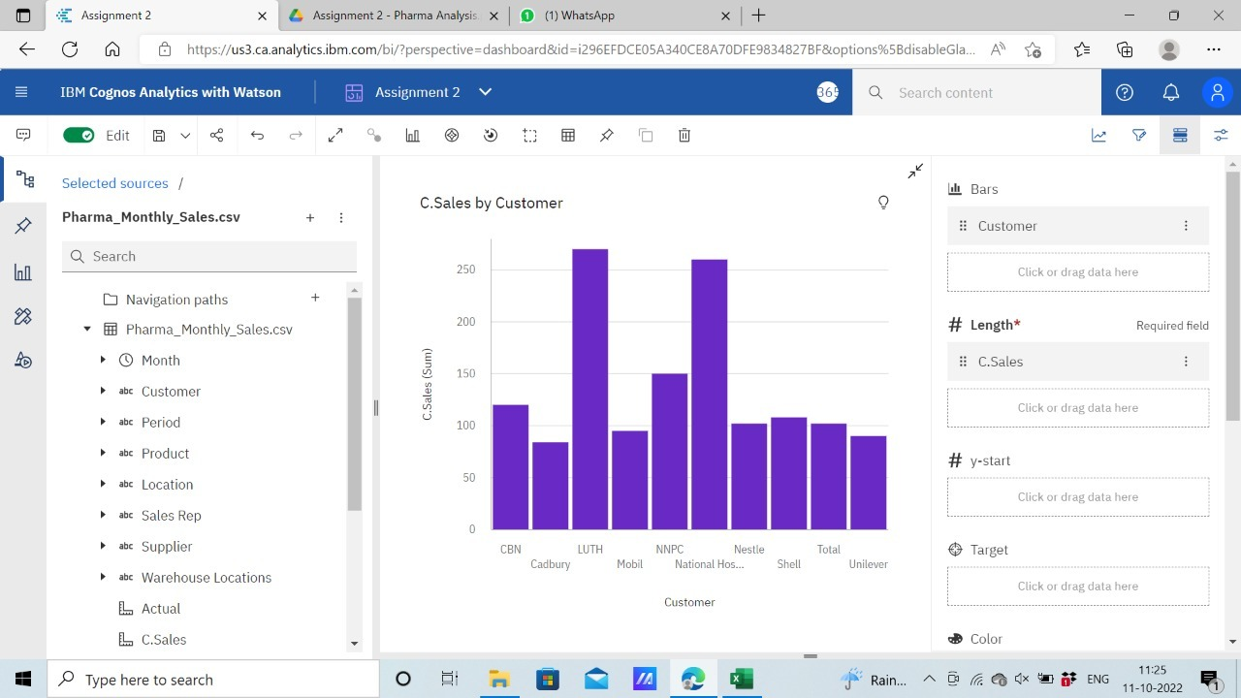

Task 2: Sales by Location.

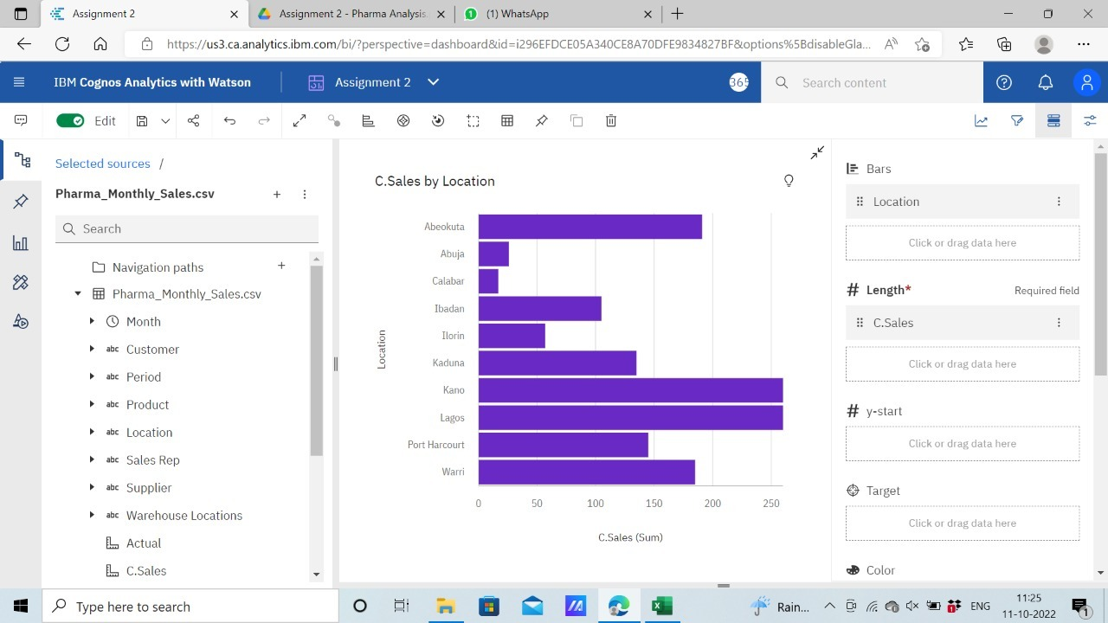

Task 3: Sales by Sales Representative.

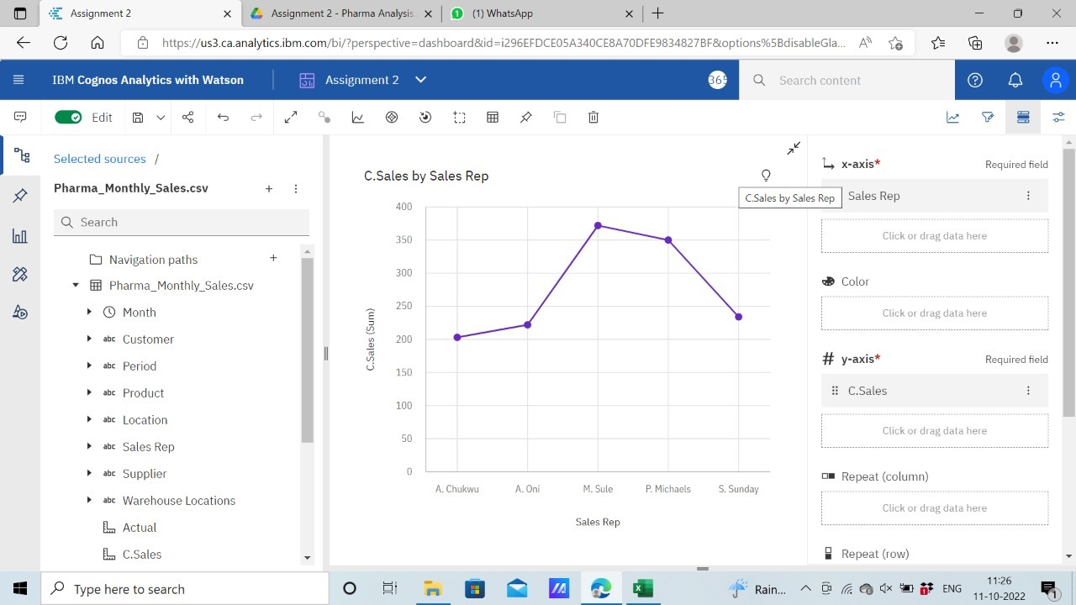

Task 4: Received Inventory from Supplier

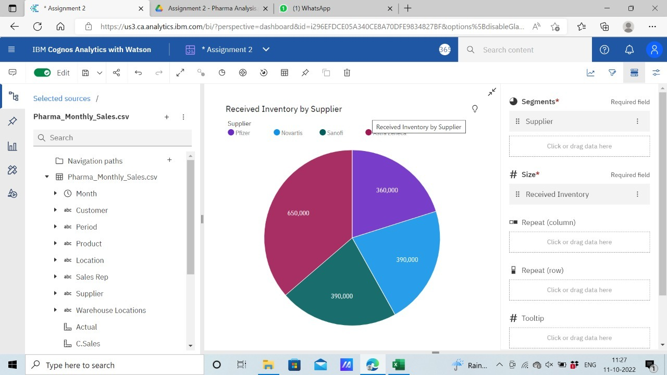

Task 5: Inventory Stock for Warehouse Locations

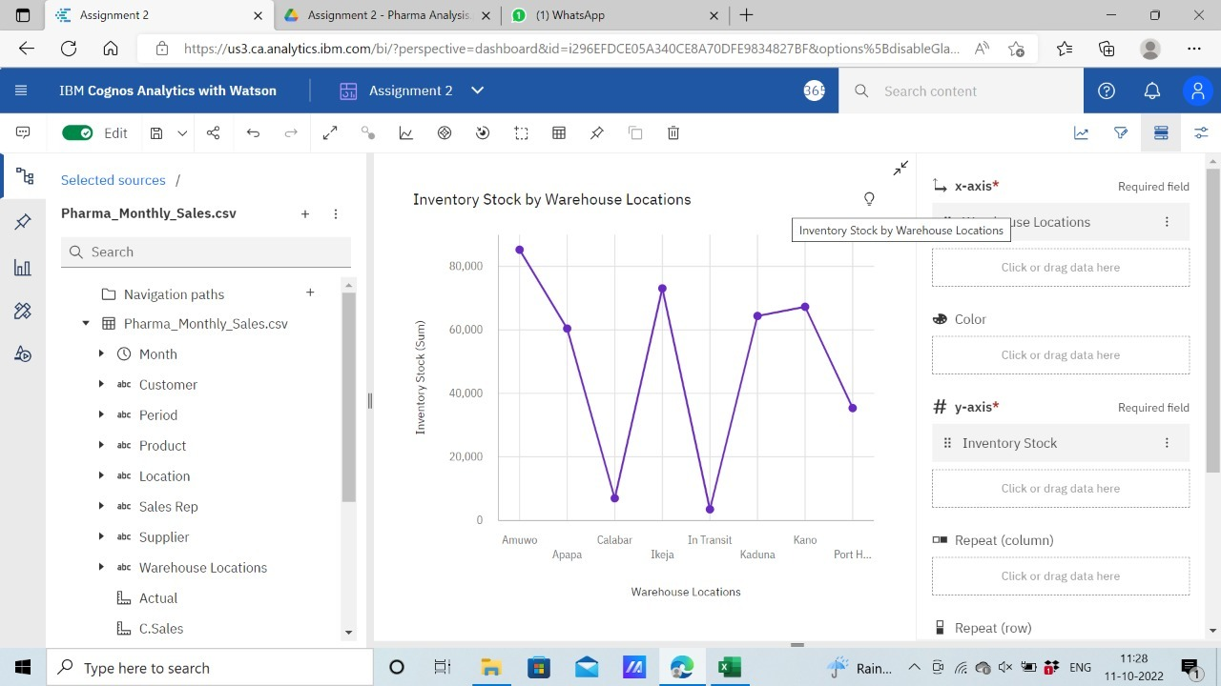

Task 6: Sales Trend

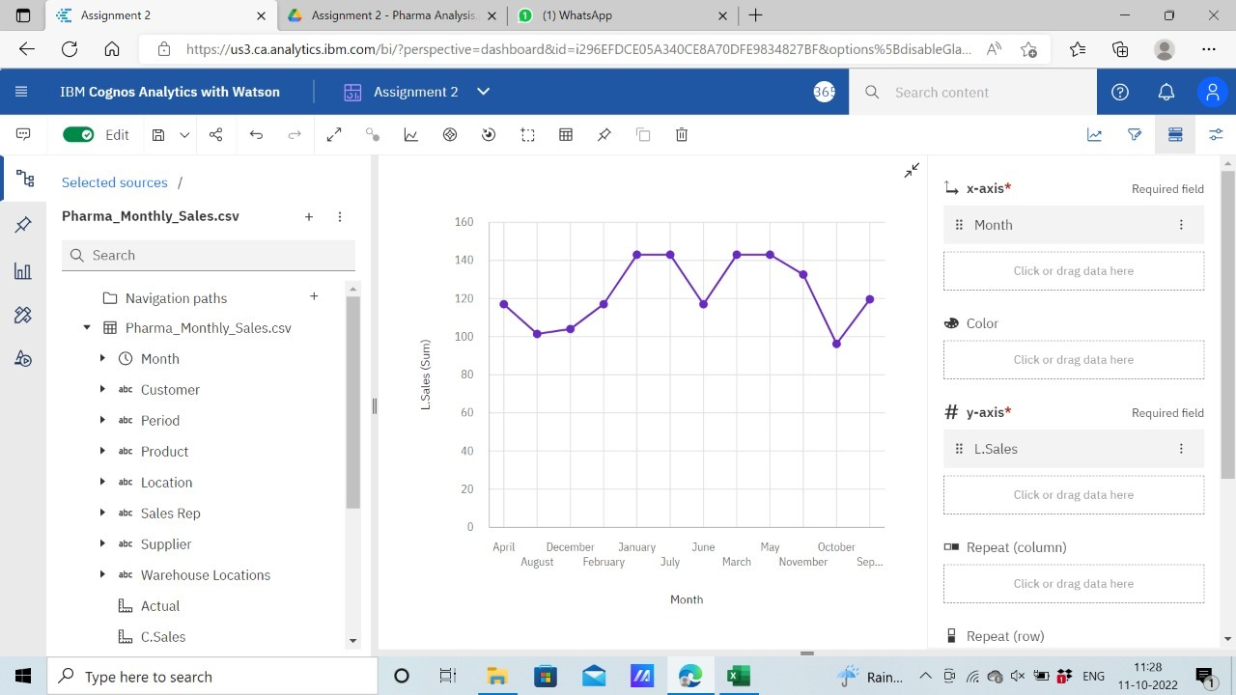

Task 7: Monthly Sales

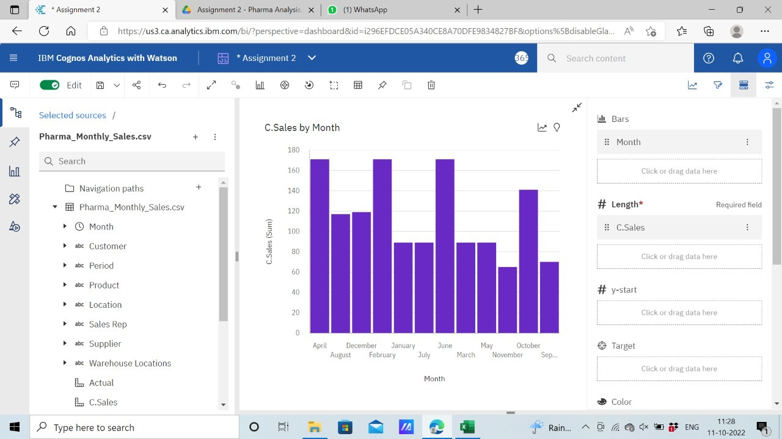

Task 8: Actual and Received Inventory by Month

